

**VIRGINIA COMMONWEALTH UNIVERSITY**

**Statistical analysis and modelling (SCMA 632)**

**A6b: Volatility Modelling and Commodity Price Analysis Using ARCH/GARCH and VAR/VECM Models**

**Lakshmy Cherussery Jayaprakash**

**V01110023**

**Date of Submission: 26-07-2024**

**CONTENTS**

|  |  |  |
| --- | --- | --- |
| **Sl. No.** | **Title** | **Page No.** |
| **1.** | Introduction | **1** |
| **2.** | Objective | **2** |
| **3.** | Business Significance | **3** |
| **4.** | Results & Interpretations- R | **4-10** |
| **5.** | Results & Interpretations-Python | **11-18** |
| **6.** | Recommendations | **19** |

**Introduction**

This analysis is divided into two parts: Part A focuses on assessing and modelling volatility using ARCH and GARCH models on stock data, while Part B delves into modelling the relationships among various commodity prices using VAR and VECM models. The goal is to understand the volatility dynamics of stock returns and the long-term equilibrium relationships among commodity prices, which are critical for making informed financial and investment decisions.

**Objective**

• **Part A**: To check for ARCH/GARCH effects, fit an appropriate ARCH/GARCH model to stock return data, and forecast the three-month volatility.

• **Part B**: To explore and model the relationships among different commodity prices using VAR and VECM models, understanding the short-term dynamics and long-term equilibrium relationships among these commodities.

**Business Significance**

### Part A:

Volatility modelling is crucial for risk management, derivative pricing, and portfolio optimization. By understanding and forecasting volatility, financial analysts can better anticipate market movements, manage risks, and develop strategies to maximize returns while minimizing potential losses.

### Part B:

Commodities are essential for various industries, and their prices can significantly impact global markets. By understanding the relationships and long-term equilibrium among commodity prices, businesses can make better procurement, production, and investment decisions. This analysis helps in predicting price movements, managing supply chain risks, and developing hedging strategies.

**Results & Interpretations- R**

**Part A**

Check for ARCH /GARCH effects, fit an ARCH/GARCH model, and forecast the three-month volatility.

ARCH:

*---------------------------------*

* GARCH Model Fit *

*---------------------------------*

Conditional Variance Dynamics

-----------------------------------

GARCH Model : sGARCH(1,0)

Mean Model : ARFIMA(0,0,0)

Distribution : norm

Optimal Parameters

------------------------------------

Estimate Std. Error t value Pr(>|t|)

mu -0.003703 0.035540 -0.1042 0.91701

omega 0.959301 0.064046 14.9784 0.00000

alpha1 0.054078 0.050277 1.0756 0.28210

Robust Standard Errors:

Estimate Std. Error t value Pr(>|t|)

mu -0.003703 0.034030 -0.10882 0.91334

omega 0.959301 0.116705 8.21989 0.00000

alpha1 0.054078 0.086622 0.62430 0.53243

LogLikelihood : -1125.212

Information Criteria

------------------------------------

Akaike 2.8526

Bayes 2.8703

Shibata 2.8526

Hannan-Quinn 2.8594

Weighted Ljung-Box Test on Standardized Residuals

------------------------------------

statistic p-value

Lag[1] 0.2752 0.5999

Lag[2*(p+q)+(p+q)-1][2] 0.2848 0.8042

Lag[4*(p+q)+(p+q)-1][5] 0.6876 0.9253

d.o.f=0

H0 : No serial correlation

Weighted Ljung-Box Test on Standardized Squared Residuals

------------------------------------

statistic p-value

Lag[1] 0.05545 0.8138

Lag[2*(p+q)+(p+q)-1][2] 1.30383 0.4094

Lag[4*(p+q)+(p+q)-1][5] 2.25976 0.5584

d.o.f=1

Weighted ARCH LM Tests

------------------------------------

Statistic Shape Scale P-Value

ARCH Lag[2] 2.484 0.500 2.000 0.1150

ARCH Lag[4] 2.738 1.397 1.611 0.3012

ARCH Lag[6] 3.177 2.222 1.500 0.4383

Nyblom stability test

------------------------------------

Joint Statistic: 0.3588

Individual Statistics:

mu 0.05956

omega 0.16108

alpha1 0.09164

Asymptotic Critical Values (10% 5% 1%)

Joint Statistic: 0.846 1.01 1.35

Individual Statistic: 0.35 0.47 0.75

Sign Bias Test

------------------------------------

t-value prob sig

Sign Bias 0.42016 0.6745

Negative Sign Bias 0.09106 0.9275

Positive Sign Bias 0.08560 0.9318

Joint Effect 0.41101 0.9380

Adjusted Pearson Goodness-of-Fit Test:

------------------------------------

group statistic p-value(g-1)

1 20 33.20 0.022811

2 30 48.36 0.013498

3 40 65.18 0.005353

4 50 73.66 0.012874

Elapsed time : 0.05226302

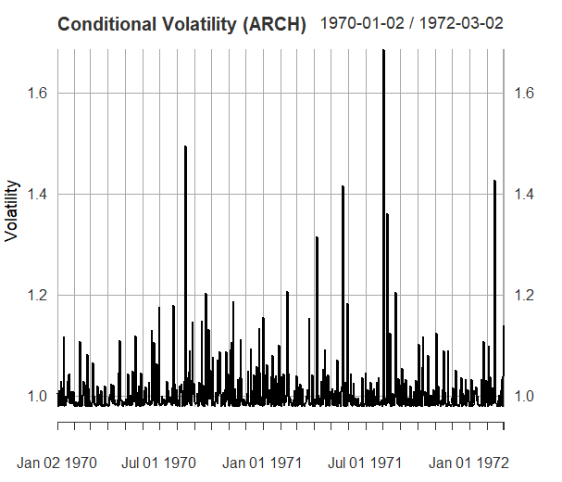

GARCH:

*---------------------------------*

* GARCH Model Fit *

*---------------------------------*

Conditional Variance Dynamics

-----------------------------------

GARCH Model : sGARCH(1,1)

Mean Model : ARFIMA(0,0,0)

Distribution : norm

Optimal Parameters

------------------------------------

Estimate Std. Error t value Pr(>|t|)

mu -0.001752 0.035713 -0.049055 0.960876

omega 0.004979 0.002926 1.701528 0.088844

alpha1 0.000000 0.002781 0.000002 0.999999

beta1 0.995296 0.000512 1943.291071 0.000000

Robust Standard Errors:

Estimate Std. Error t value Pr(>|t|)

mu -0.001752 0.032553 -0.053816 0.95708

omega 0.004979 0.004526 1.100087 0.27129

alpha1 0.000000 0.004295 0.000001 1.00000

beta1 0.995296 0.000297 3356.423518 0.00000

LogLikelihood : -1125.72

Information Criteria

------------------------------------

Akaike 2.8564

Bayes 2.8801

Shibata 2.8564

Hannan-Quinn 2.8655

Weighted Ljung-Box Test on Standardized Residuals

------------------------------------

statistic p-value

Lag[1] 0.2980 0.5851

Lag[2*(p+q)+(p+q)-1][2] 0.3211 0.7841

Lag[4*(p+q)+(p+q)-1][5] 0.7307 0.9170

d.o.f=0

H0 : No serial correlation

Weighted Ljung-Box Test on Standardized Squared Residuals

------------------------------------

statistic p-value

Lag[1] 0.2563 0.6126

Lag[2*(p+q)+(p+q)-1][5] 2.4229 0.5224

Lag[4*(p+q)+(p+q)-1][9] 7.0968 0.1912

d.o.f=2

Weighted ARCH LM Tests

------------------------------------

Statistic Shape Scale P-Value

ARCH Lag[3] 0.3154 0.500 2.000 0.5744

ARCH Lag[5] 0.3297 1.440 1.667 0.9323

ARCH Lag[7] 5.6100 2.315 1.543 0.1697

Nyblom stability test

------------------------------------

Joint Statistic: 0.6908

Individual Statistics:

mu 0.06485

omega 0.07239

alpha1 0.07516

beta1 0.07210

Asymptotic Critical Values (10% 5% 1%)

Joint Statistic: 1.07 1.24 1.6

Individual Statistic: 0.35 0.47 0.75

Sign Bias Test

------------------------------------

t-value prob sig

Sign Bias 0.3086 0.7577

Negative Sign Bias 0.8356 0.4036

Positive Sign Bias 0.6395 0.5227

Joint Effect 1.5196 0.6778

Adjusted Pearson Goodness-of-Fit Test:

------------------------------------

group statistic p-value(g-1)

1 20 35.93 0.010773

2 30 51.24 0.006622

3 40 74.99 0.000466

4 50 85.04 0.001075

Elapsed time : 0.134357

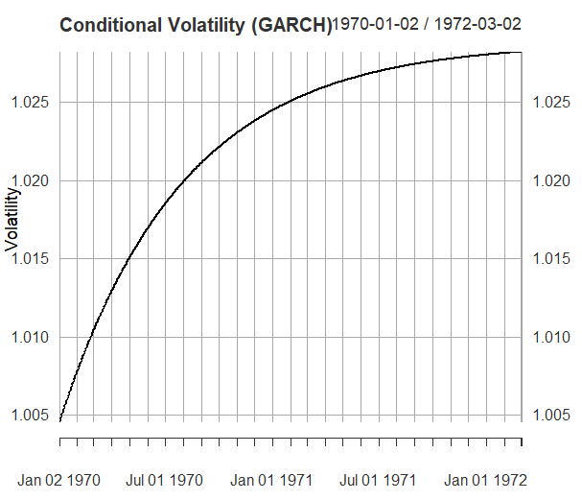

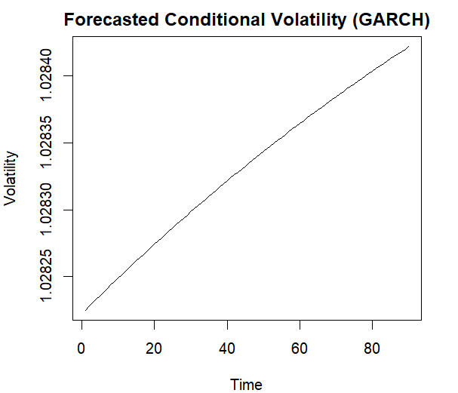

**Part B**

VAR, VECM model

######################

# Johansen-Procedure #

######################

Test type: maximal eigenvalue statistic (lambda max) , without linear trend and constant in cointegration

Eigenvalues (lambda):

[1] 1.156801e-01 8.619179e-02 5.620394e-02 4.076726e-02 2.275358e-02 1.194827e-02 5.190418e-19

Values of teststatistic and critical values of test:

test 10pct 5pct 1pct

r <= 5 | 9.28 7.52 9.24 12.97

r <= 4 | 17.77 13.75 15.67 20.20

r <= 3 | 32.13 19.77 22.00 26.81

r <= 2 | 44.66 25.56 28.14 33.24

r <= 1 | 69.58 31.66 34.40 39.79

r = 0 | 94.91 37.45 40.30 46.82

Eigenvectors, normalised to first column:

(These are the cointegration relations)

crude_brent.l1 soybeans.l1 gold.l1 silver.l1 urea_ee_bulk.l1 maize.l1 constant

crude_brent.l1 1.00000000 1.0000000 1.000000000 1.00000000 1.00000000 1.000000 1.00000000

soybeans.l1 -0.16154239 -1.4321403 0.901085840 -0.14719252 0.03370700 2.048932 0.28856030

gold.l1 0.03783477 0.1479103 0.001789928 0.02571265 -0.09950777 3.345395 -1.01068667

silver.l1 -7.95952405 -14.0314441 -7.103954542 -0.32544022 2.21141248 -134.220502 11.82633401

urea_ee_bulk.l1 -0.30355383 0.9616092 0.067413992 -0.07126188 0.01058682 -4.056949 0.06530194

maize.l1 1.07547641 1.2691927 -1.729400316 -0.21063171 0.12487178 21.968289 0.41242334

constant -22.96337452 105.7113165 -23.503233951 37.64682683 -28.47397614 -1093.494591 596.80024624

Weights W:

(This is the loading matrix)

crude_brent.l1 soybeans.l1 gold.l1 silver.l1 urea_ee_bulk.l1 maize.l1 constant

crude_brent.d -0.007005927 -0.004539234 -0.004197083 -0.019364170 -0.015848064 1.954733e-05 4.435138e-19

soybeans.d -0.047222018 0.021223505 -0.048662433 0.116835928 -0.071054269 -9.850516e-05 2.136425e-17

gold.d 0.018928184 0.013629275 0.044732209 0.103019348 -0.055534389 9.002896e-04 6.806274e-19

silver.d 0.006889065 0.000770840 0.003128917 0.001721054 -0.004296816 1.568478e-05 -1.681467e-19

urea_ee_bulk.d 0.123335190 -0.080324042 -0.022293481 0.172553471 -0.013186723 3.241271e-05 -4.322800e-18

maize.d -0.070678599 -0.002573286 0.015159904 0.040701554 -0.025688634 -8.129777e-05 1.029687e-18

summary(vecm)

Length Class Mode

rlm 12 mlm list

beta 7 -none- numeric

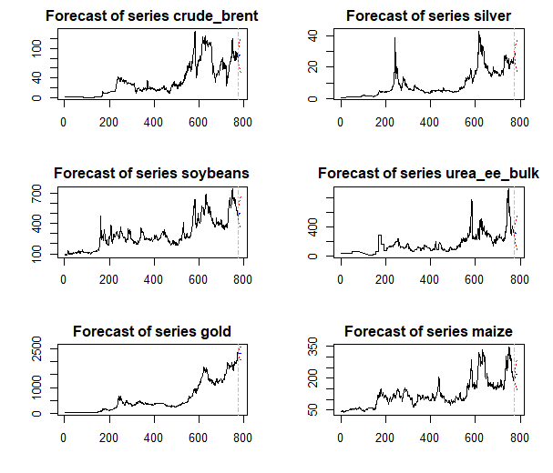

**Results & Interpretations- Python**

**Part A**

Check for ARCH /GARCH effects, fit an ARCH/GARCH model, and forecast the three-month volatility

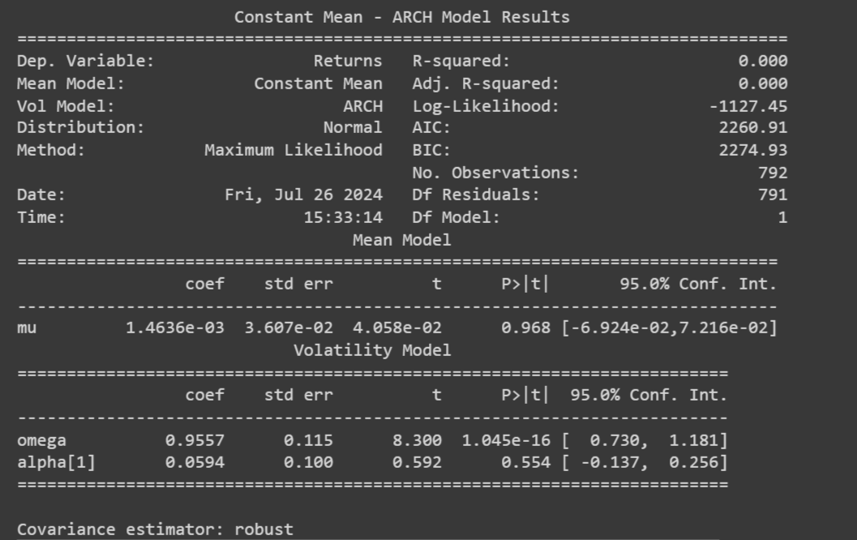

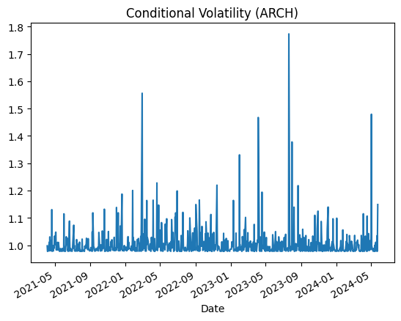

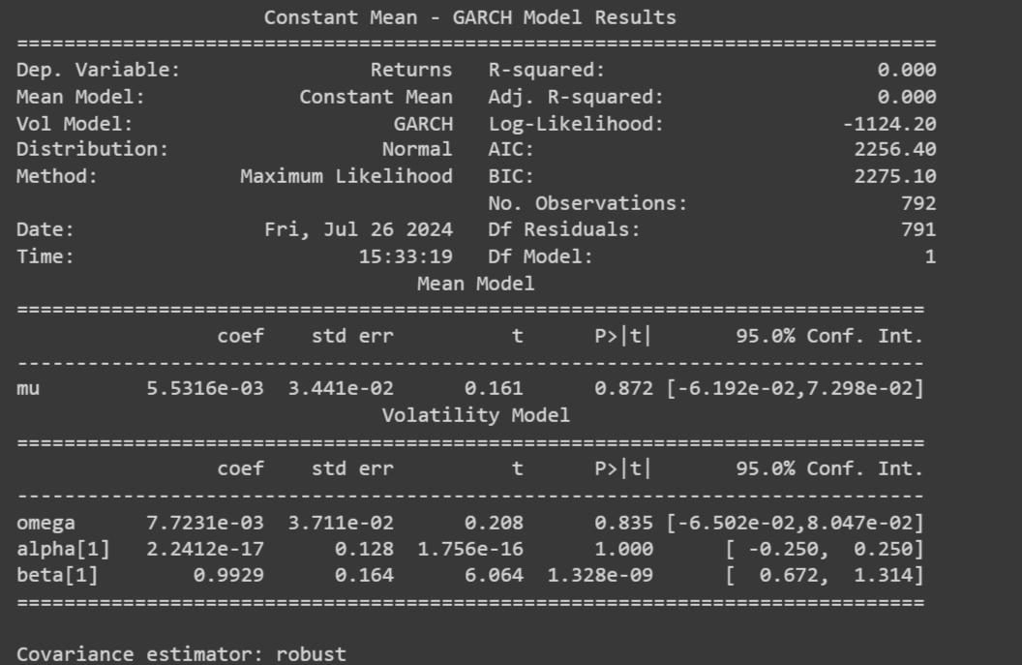

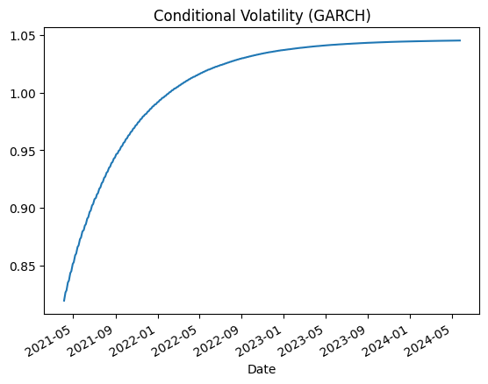

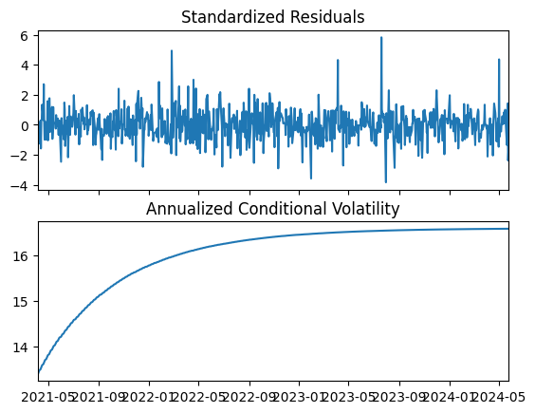

**Part B**

VAR, VECM model

vecm_fit.summary:

Det. terms outside the coint. relation & lagged endog. parameters for equation CRUDE_BRENT

===================================================================================

coef std err z P>|z| [0.025 0.975]

-----------------------------------------------------------------------------------

L1.CRUDE_BRENT 0.3380 0.037 9.224 0.000 0.266 0.410

L1.SOYBEANS 0.0074 0.007 0.981 0.326 -0.007 0.022

L1.GOLD -0.0020 0.006 -0.325 0.745 -0.014 0.010

L1.SILVER -0.0633 0.148 -0.428 0.668 -0.353 0.226

L1.UREA_EE_BULK -0.0134 0.004 -3.162 0.002 -0.022 -0.005

L1.MAIZE 0.0304 0.016 1.871 0.061 -0.001 0.062

Det. terms outside the coint. relation & lagged endog. parameters for equation SOYBEANS

===================================================================================

coef std err z P>|z| [0.025 0.975]

-----------------------------------------------------------------------------------

L1.CRUDE_BRENT 0.1454 0.202 0.720 0.471 -0.250 0.541

L1.SOYBEANS 0.0653 0.041 1.580 0.114 -0.016 0.146

L1.GOLD 0.0009 0.033 0.028 0.978 -0.064 0.066

L1.SILVER 0.4140 0.814 0.509 0.611 -1.181 2.009

L1.UREA_EE_BULK -0.0095 0.023 -0.408 0.683 -0.055 0.036

L1.MAIZE 0.3092 0.090 3.452 0.001 0.134 0.485

Det. terms outside the coint. relation & lagged endog. parameters for equation GOLD

===================================================================================

coef std err z P>|z| [0.025 0.975]

-----------------------------------------------------------------------------------

L1.CRUDE_BRENT 0.2138 0.305 0.702 0.483 -0.383 0.811

L1.SOYBEANS 0.0066 0.062 0.106 0.916 -0.116 0.129

L1.GOLD 0.2188 0.050 4.351 0.000 0.120 0.317

L1.SILVER 0.1831 1.229 0.149 0.882 -2.225 2.591

L1.UREA_EE_BULK -0.0959 0.035 -2.720 0.007 -0.165 -0.027

L1.MAIZE 0.1980 0.135 1.465 0.143 -0.067 0.463

Det. terms outside the coint. relation & lagged endog. parameters for equation SILVER

===================================================================================

coef std err z P>|z| [0.025 0.975]

-----------------------------------------------------------------------------------

L1.CRUDE_BRENT 0.0123 0.012 1.002 0.316 -0.012 0.036

L1.SOYBEANS 0.0030 0.003 1.179 0.239 -0.002 0.008

L1.GOLD -0.0016 0.002 -0.807 0.420 -0.006 0.002

L1.SILVER 0.3240 0.050 6.525 0.000 0.227 0.421

L1.UREA_EE_BULK -0.0014 0.001 -0.978 0.328 -0.004 0.001

L1.MAIZE 0.0040 0.005 0.731 0.465 -0.007 0.015

Det. terms outside the coint. relation & lagged endog. parameters for equation UREA_EE_BULK

===================================================================================

coef std err z P>|z| [0.025 0.975]

-----------------------------------------------------------------------------------

L1.CRUDE_BRENT 1.8092 0.305 5.924 0.000 1.211 2.408

L1.SOYBEANS 0.1510 0.063 2.417 0.016 0.029 0.274

L1.GOLD 0.0820 0.050 1.628 0.104 -0.017 0.181

L1.SILVER -2.4881 1.231 -2.020 0.043 -4.902 -0.074

L1.UREA_EE_BULK 0.1716 0.035 4.856 0.000 0.102 0.241

L1.MAIZE 0.1382 0.135 1.020 0.308 -0.127 0.404

Det. terms outside the coint. relation & lagged endog. parameters for equation MAIZE

===================================================================================

coef std err z P>|z| [0.025 0.975]

-----------------------------------------------------------------------------------

L1.CRUDE_BRENT -0.0108 0.088 -0.122 0.903 -0.184 0.163

L1.SOYBEANS 0.0213 0.018 1.178 0.239 -0.014 0.057

L1.GOLD -0.0275 0.015 -1.887 0.059 -0.056 0.001

L1.SILVER 0.5667 0.357 1.589 0.112 -0.132 1.266

L1.UREA_EE_BULK 0.0120 0.010 1.170 0.242 -0.008 0.032

L1.MAIZE 0.2159 0.039 5.501 0.000 0.139 0.293

Loading coefficients (alpha) for equation CRUDE_BRENT

==============================================================================

coef std err z P>|z| [0.025 0.975]

------------------------------------------------------------------------------

ec1 -0.0128 0.006 -2.289 0.022 -0.024 -0.002

Loading coefficients (alpha) for equation SOYBEANS

==============================================================================

coef std err z P>|z| [0.025 0.975]

------------------------------------------------------------------------------

ec1 -0.0138 0.031 -0.450 0.653 -0.074 0.046

Loading coefficients (alpha) for equation GOLD

==============================================================================

coef std err z P>|z| [0.025 0.975]

------------------------------------------------------------------------------

ec1 0.0427 0.046 0.921 0.357 -0.048 0.134

Loading coefficients (alpha) for equation SILVER

==============================================================================

coef std err z P>|z| [0.025 0.975]

------------------------------------------------------------------------------

ec1 0.0088 0.002 4.678 0.000 0.005 0.012

Loading coefficients (alpha) for equation UREA_EE_BULK

==============================================================================

coef std err z P>|z| [0.025 0.975]

------------------------------------------------------------------------------

ec1 0.0943 0.046 2.028 0.043 0.003 0.185

Loading coefficients (alpha) for equation MAIZE

==============================================================================

coef std err z P>|z| [0.025 0.975]

------------------------------------------------------------------------------

ec1 -0.0786 0.013 -5.836 0.000 -0.105 -0.052

Cointegration relations for loading-coefficients-column 1

==============================================================================

coef std err z P>|z| [0.025 0.975]

------------------------------------------------------------------------------

beta.1 1.0000 0 0 0.000 1.000 1.000

beta.2 -0.2688 0.055 -4.854 0.000 -0.377 -0.160

beta.3 0.0472 0.011 4.125 0.000 0.025 0.070

beta.4 -7.1594 0.793 -9.025 0.000 -8.714 -5.605

beta.5 -0.1998 0.033 -5.996 0.000 -0.265 -0.134

beta.6 0.9148 0.134 6.848 0.000 0.653 1.177

==============================================================================

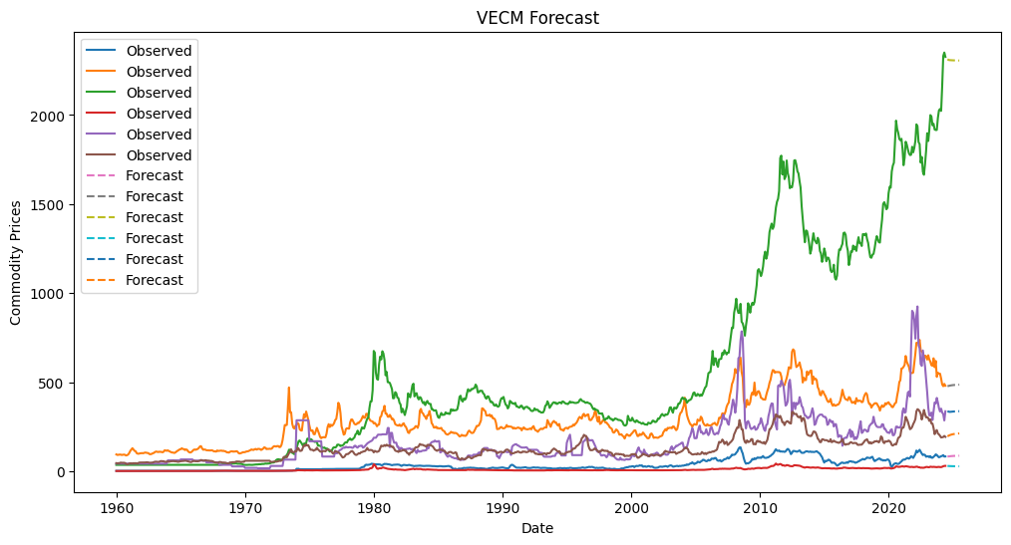

**Recommendations**

Monitor the long-term equilibrium relationships to make informed procurement and investment decisions. Use the short-term dynamics identified by the VAR model for trading strategies and risk management. Regularly update the models with new data to capture any structural changes in the relationships among commodities.